**“A112- Eco Bins” (Aqlli urnalar) startap loyihasini o‘rganish bo‘yicha**

**DALOLATNOMA**

**“____”________2025-yil Baliqchi tumani**

2024-yilda Oliy ta’lim, fan va innovatsiyalar vazirligi huzuridagi Innovatsion rivojlanish agentligi hamda Qishloq xo‘jaligi vazirligi huzuridagi Oziq-ovqat va qishloq xo‘jaligi sohasida strategik rivojlanish va tadqiqotlar xalqaro markazi hamkorligida moliyalashtirilgan **““A112- Eco Bins” (Aqlli urnalar)”** startap loyihasi monitoringi Oliy ta’lim, fan va innovatsiyalar boshqarmasi innovatsion rivojlanish sho‘basi mudiri B.Turg’unov, Oliy ta’lim, fan va innovatsiyalar boshqarmasi innovatsion rivojlanish sho‘basi bosh mutahassisi J.Xolmatjonov, **“Biznes Legion”** **MChJ** direktori D.Komiljonov va tashkilot hisobchisi M.Komiljonovalarishtirokida o‘rganildi.

**Mablagʻ yoʻnaltirilgan yoʻnalishlar**

|  |  |  |  |
| --- | --- | --- | --- |
| **№** | **Loyiha yoʻnalishlari** | **Agentlik tomonidan ajratilgan mablag‘**  (ming so‘m) | **Talabgorning o‘z mablag‘lari hisobidan**  (ming so‘m) |
|  | Inventar, texnika va jihozlarni xarid qilish xarajatlari. | 57 000,0 | 0 |
|  | Xodimlarga to‘lanadigan ish haqi va ijtimoiy soliq to‘lov xarajatlari. | 47 620,0 | 0 |
|  | Xomashyo va materiallarni sotib olish xarajatlari. | 45 000,0 | 0 |
|  | Boshqa xarajatlar.  Logistika harajatlari | 5 700,0 | 0 |
|  | Ijara xarajatlari | 22 800 | 0 |
| **Jami** | | **180 120,0** | **0** |

**O‘tkazilgan monitoring natijasida quyidagilar aniqlandi:**

1. Loyiha doirasida xarid qilingan inventar, texnika va jihozlar inventarizatsiyadan o‘tkazildi (1-ilova)
2. Loyiha doirasida yaratilgan ish o‘rni va mehnatga haq to‘lash xarajatlari tekshirildi (2-ilova)
3. Loyiha doirasida xom-ashyo va materiallarni xarid qilinganligi bo‘yicha shartnoma va hisob fakturalar tekshirildi (3-ilova)
4. Loyiha doirasida boshqa xajaratlar uchun sarf qilingan hujjatlar tekshirildi

(4-ilova)

1. Loyiha doirasida Sotuv bo’yichava kelib tushgan mablag’lar hujjatlar tekshirildi (5-ilova)

***\*Bayonnomaga barcha zarur xujjatlar ilova qilinadi.***

**Andijon viloyati oliy ta’lim, fan va**

**innovatsiyalar boshqarmasi**

**innovatsion rivojlanish**

**sho‘basi mudiri B.Turg’unov**

**Andijon viloyati oliy ta’lim, fan va**

**innovatsiyalar boshqarmasi**

**innovatsion rivojlanish**

**sho‘basi bosh mutahasisi J. Xolmatjonov**

**“Biznes Legion”**

**MChJ direktori D.Komiljonov**

**“Biznes Legion”**

**MChJ hisobchisi M. Komiljonova**

**O‘rganishga oid fotosuratlar**

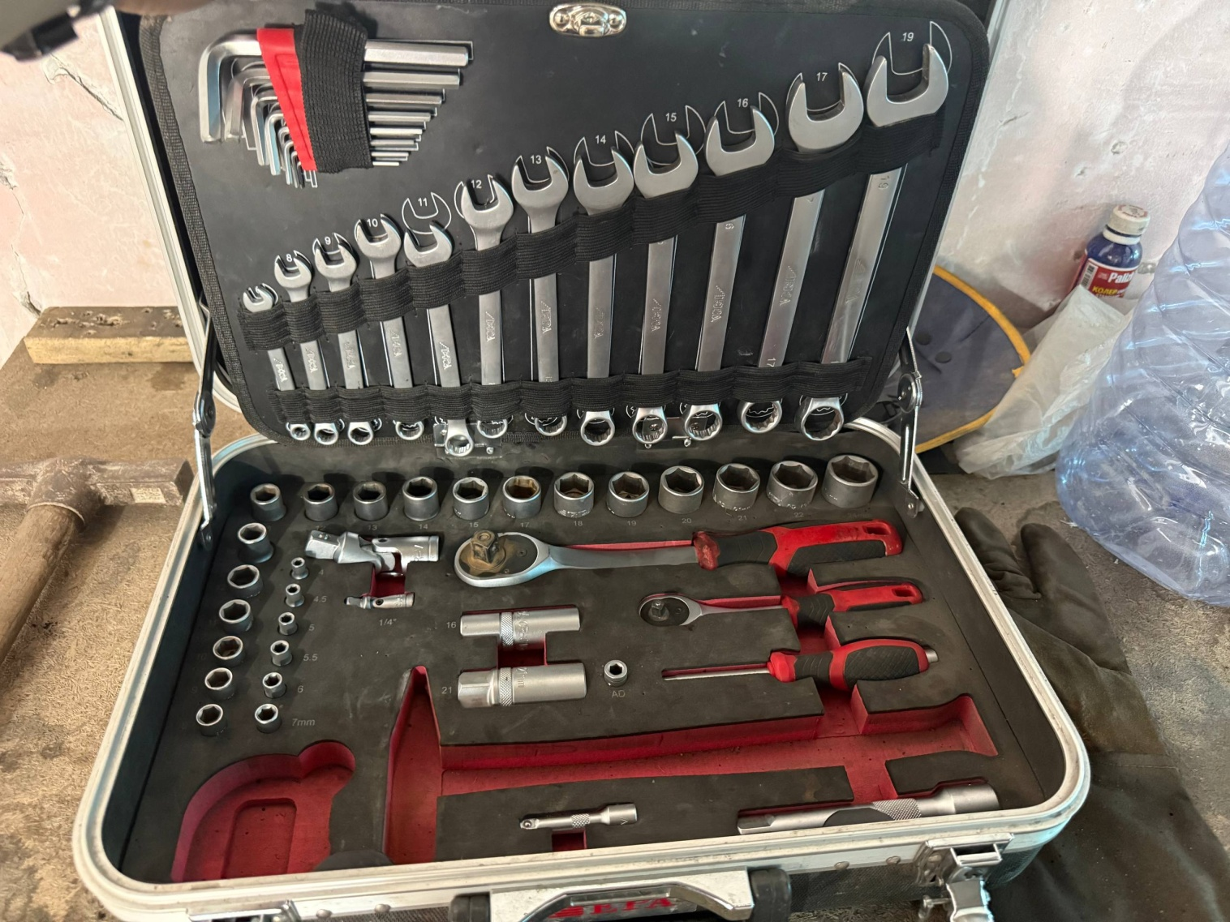

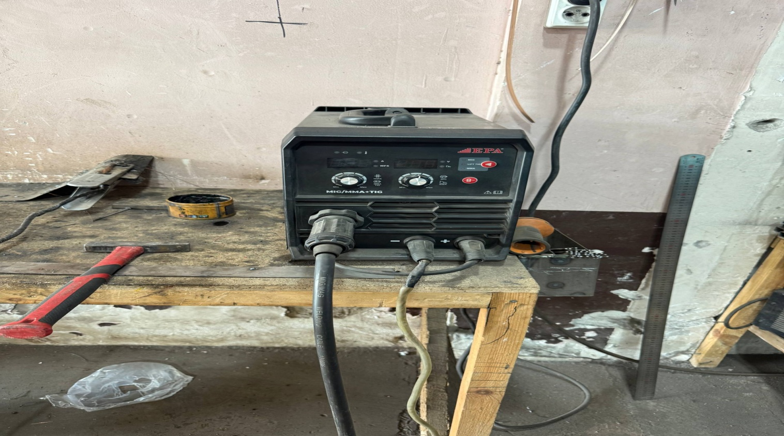

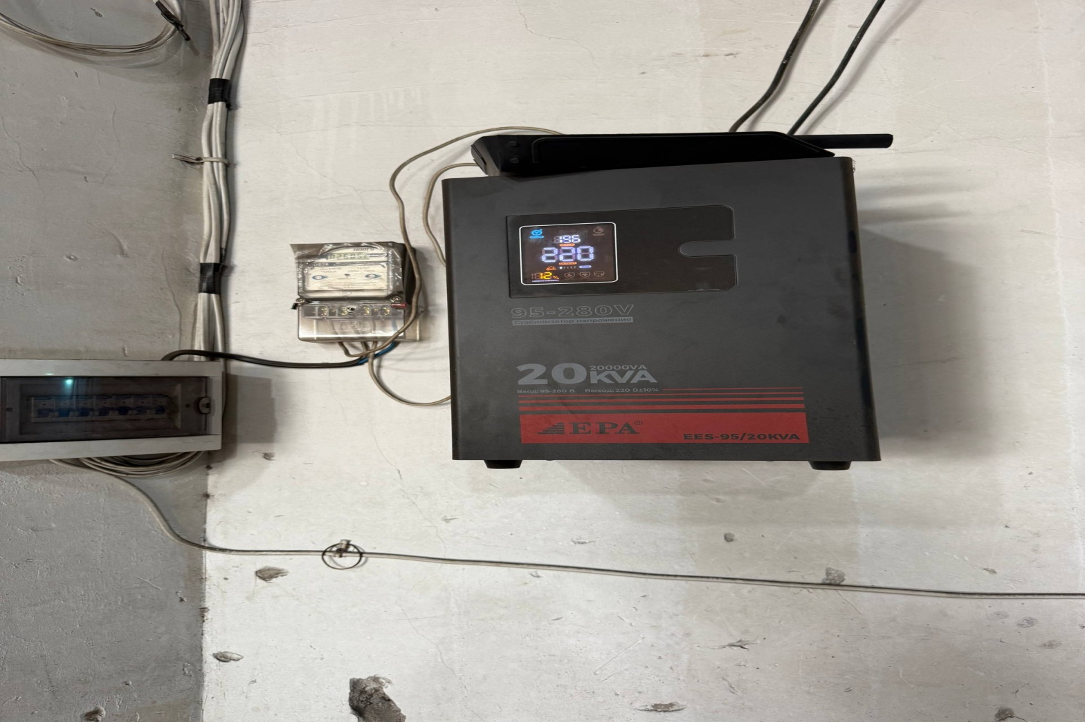

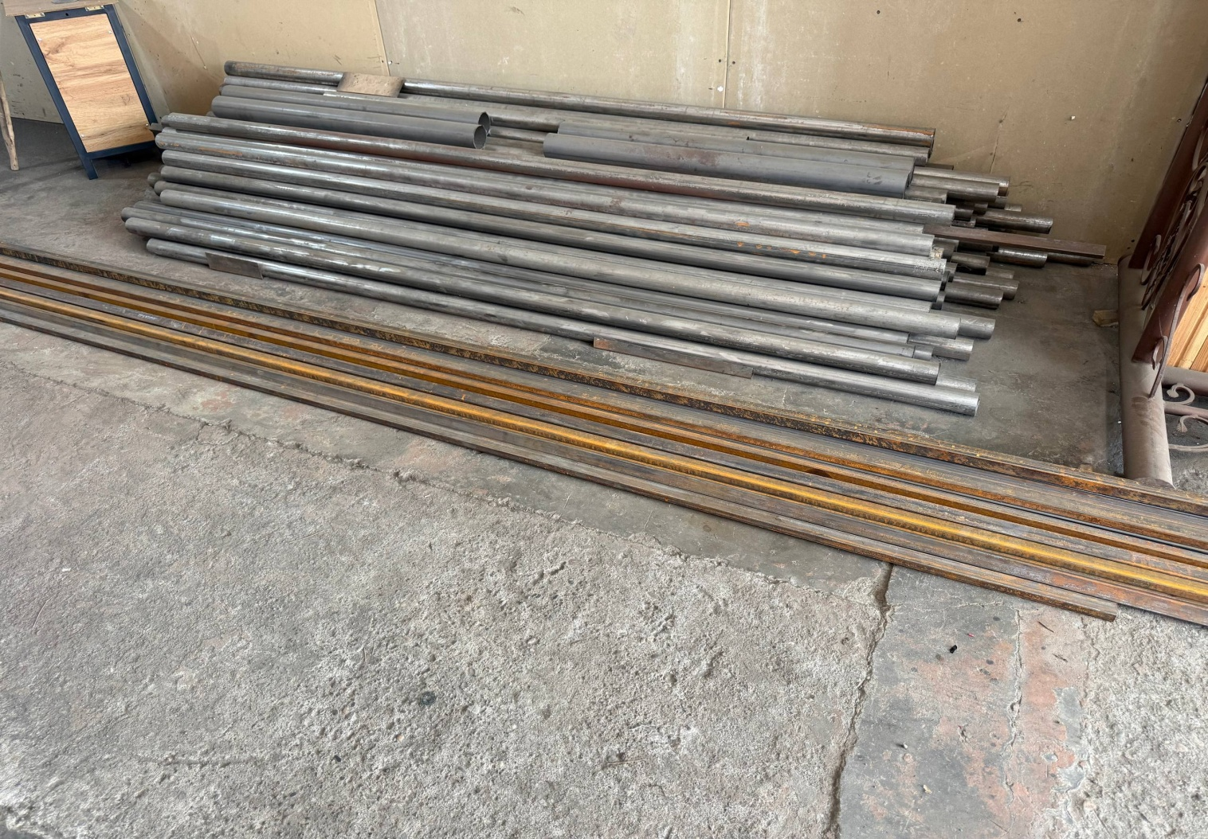

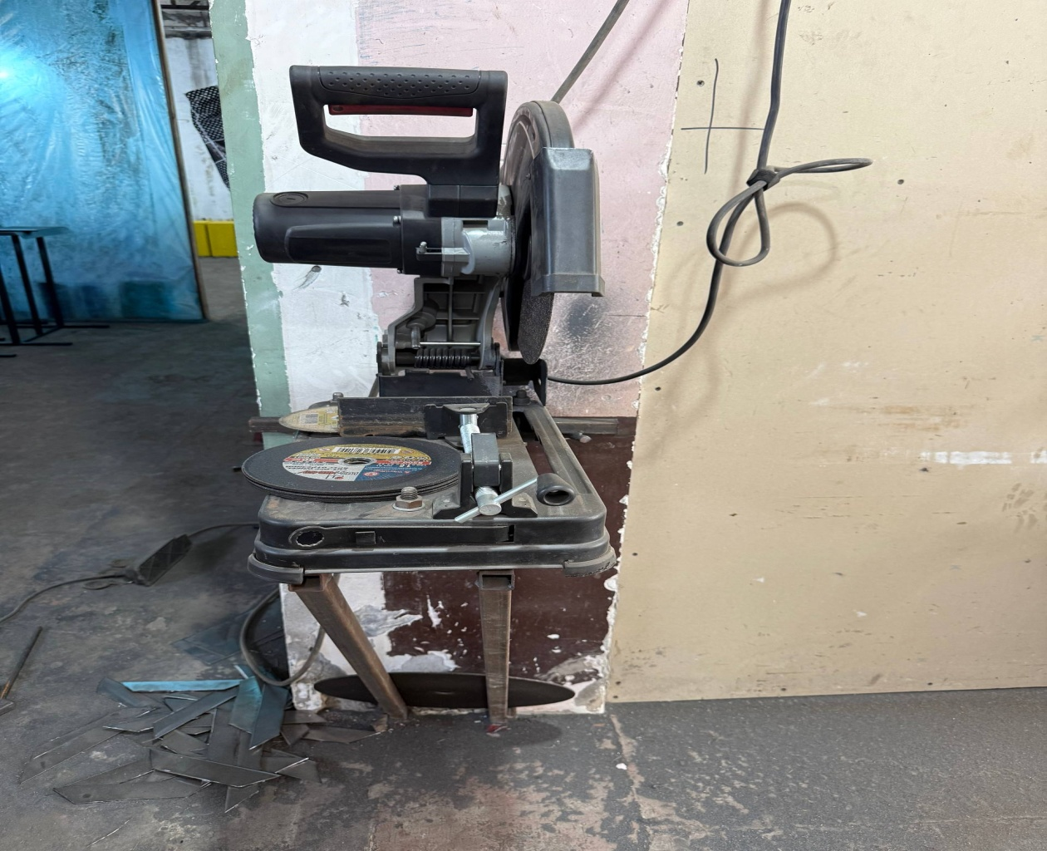

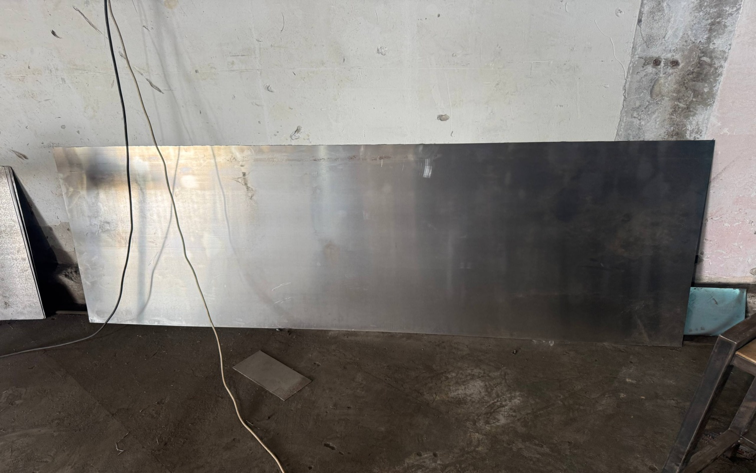

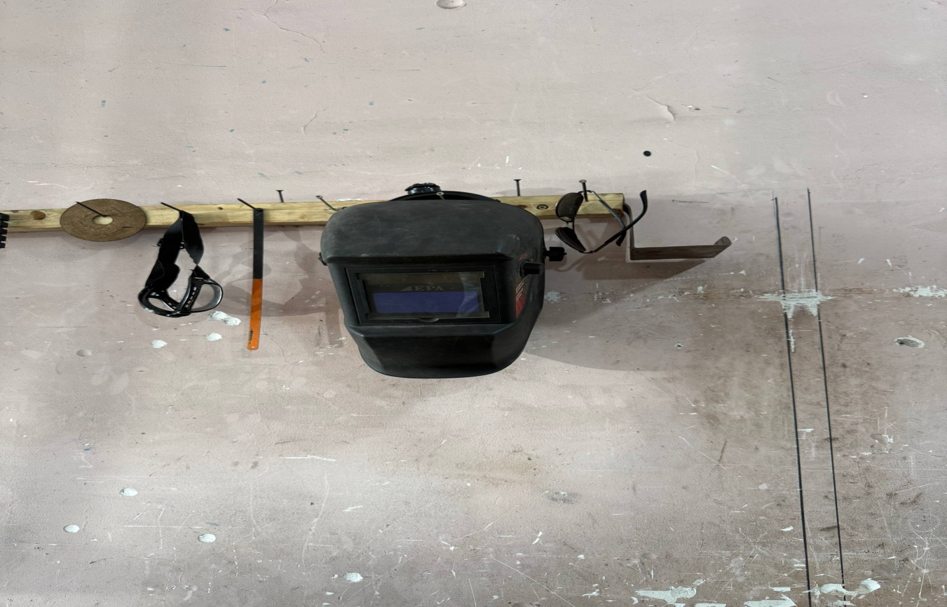

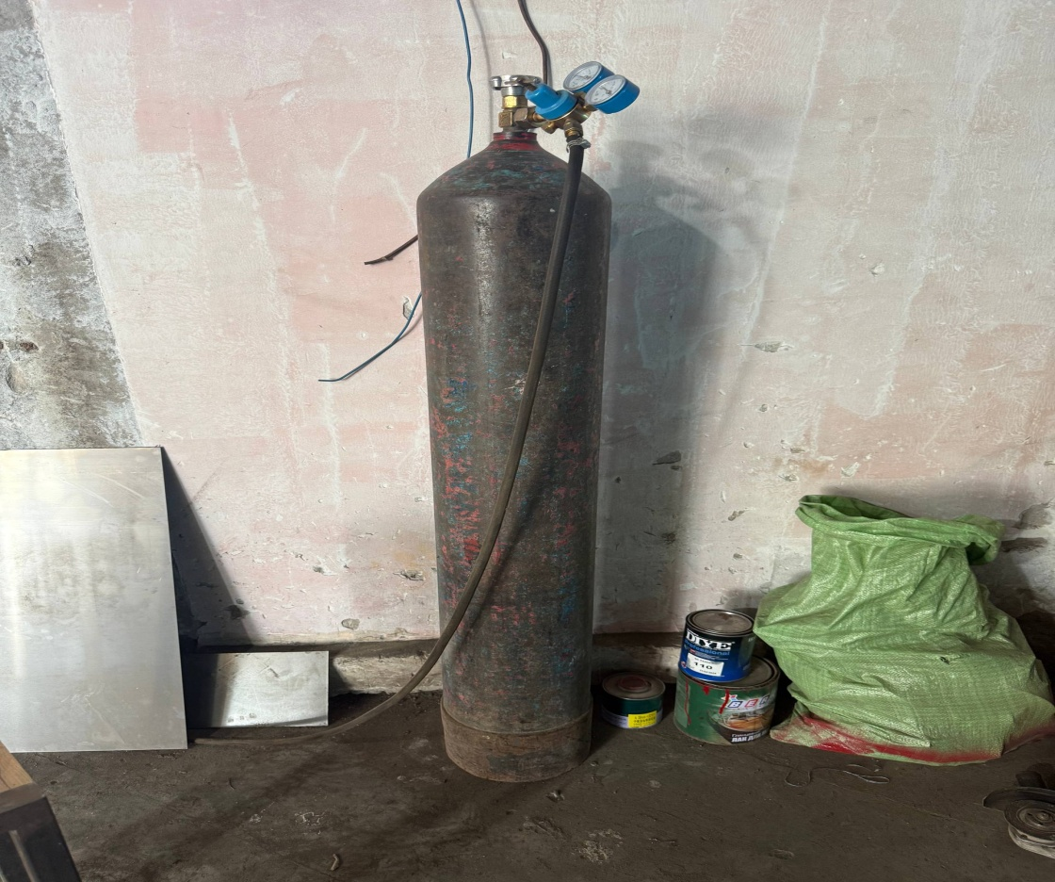

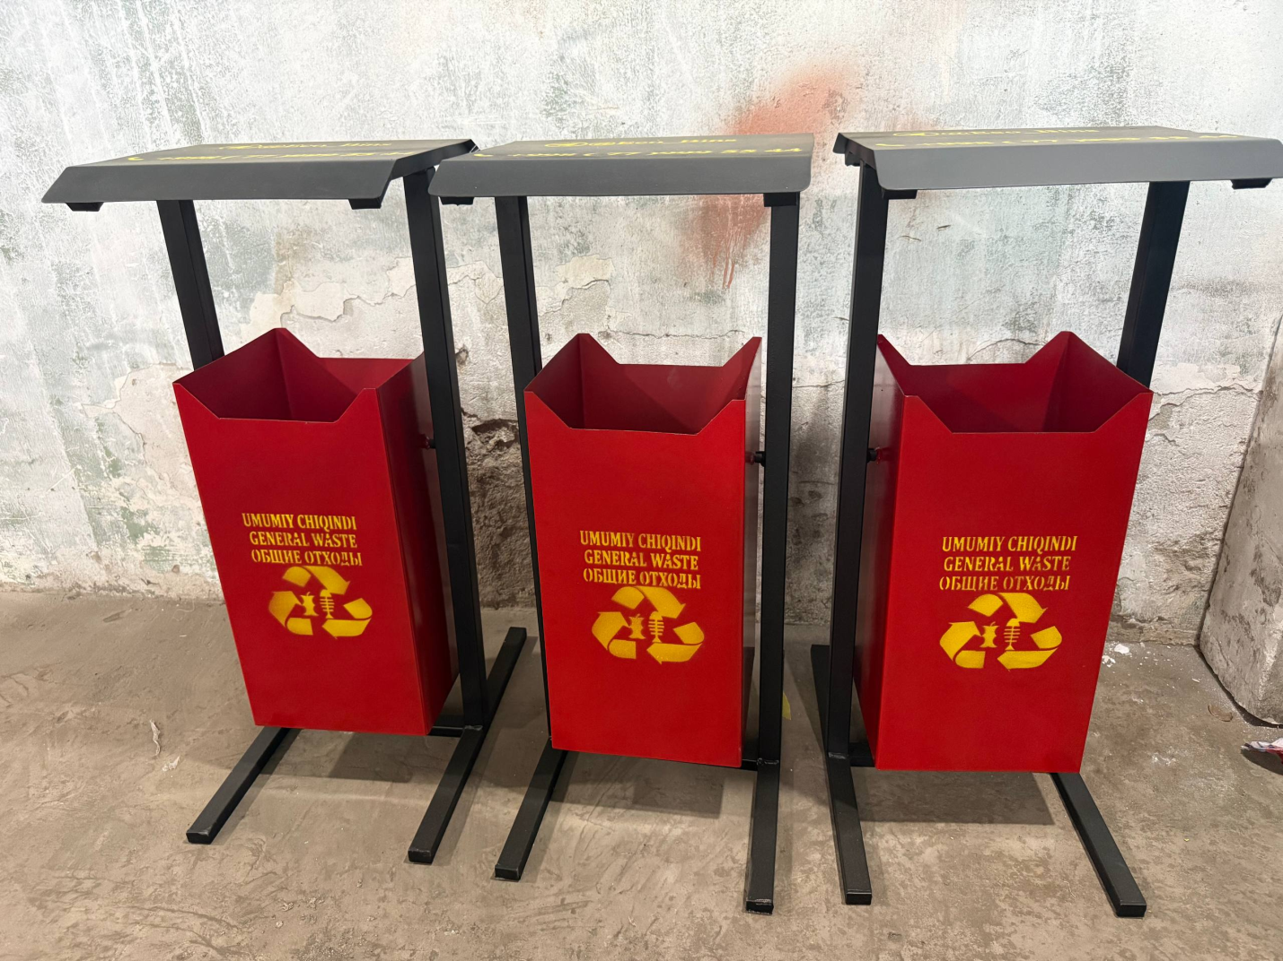

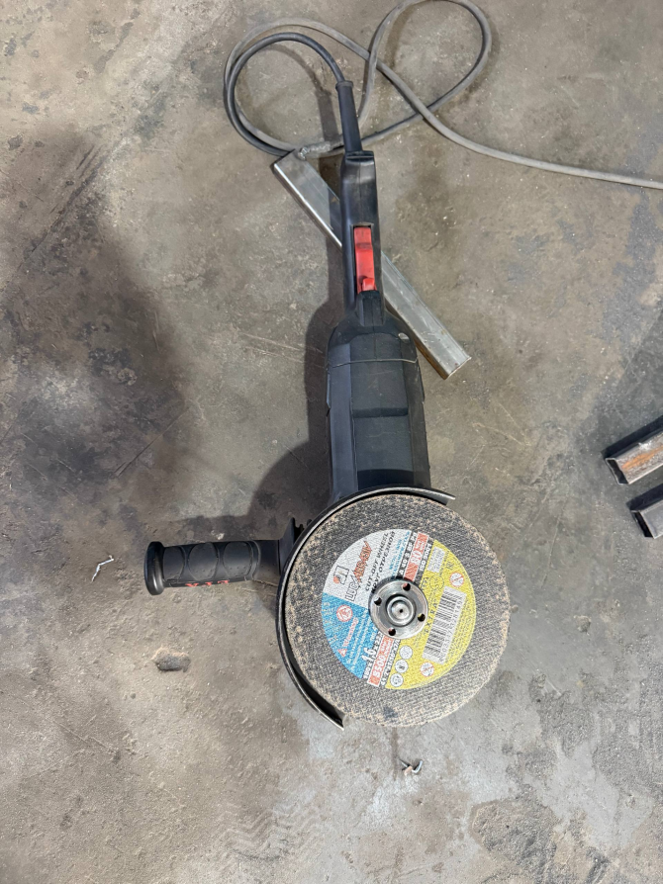

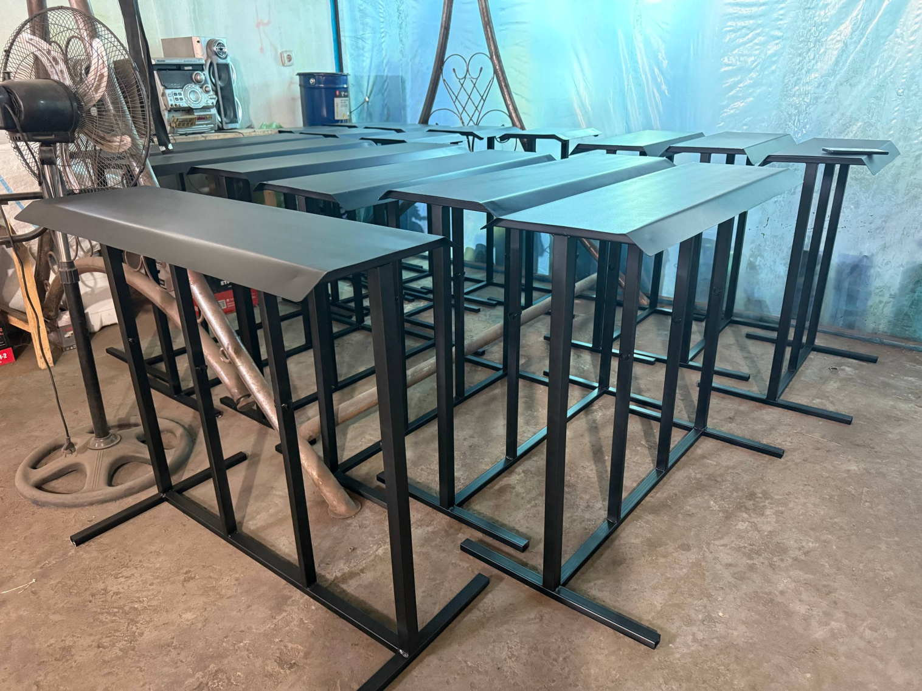

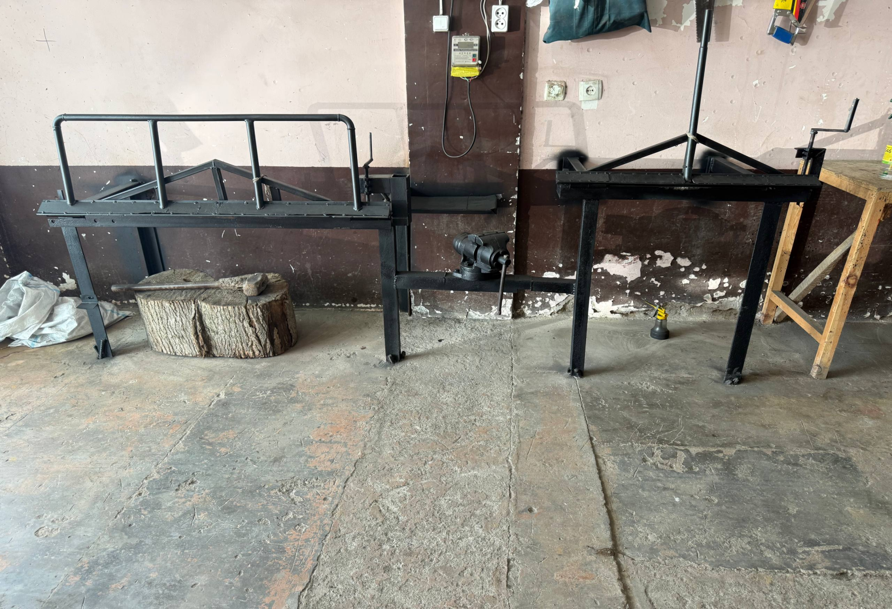

**Xarid qilingan inventar, texnika va jihozlar ro’yhati**  **1-ilova**

|  |  |  |  |  |  |  |  |
| --- | --- | --- | --- | --- | --- | --- | --- |
| **№** | **Inventar, texnika va jihoz** | **O‘lchov birligi** | **Miqdori** | **Narxi** (ming so‘mda) | **Summasi** *(*ming so‘mda*)* | **Moliyalashtirish manbasi** | **Xarid qilingan va loyiha hujjatlaridagi inventar texnikalarning**  **farqi** |
| 1 | Balgarka | dona | 1 | 2 000,0 | 2 000,0 | 2 000,0 | **Mavjud emas** |
| 2 | Shurupover | dona | 1 | 500,0 | 500,0 | 500,0 |  |
| 3 | Tarsovka akfa | dona | 1 | 2 000,0 | 2 000,0 | 2 000,0 | **Mavjud emas** |
| 4 | Svarka pol avtomat | dona | 1 | 7 000,0 | 7 000,0 | 7 000,0 | **Mavjud emas** |
| 5 | Kislarod balon | dona | 1 | 2 000,0 | 2 000,0 | 2 000,0 | **Mavjud emas** |
| 6 | Reduktor | dona | 1 | 500,0 | 500,0 | 500,0 | **Mavjud emas** |
| 7 | Stalbizator 20kv | dona | 1 | 6 000,0 | 6 000,0 | 6 000,0 | **Mavjud emas** |
| 8 | Kompressor | dona | 1 | 4 000,0 | 4 000,0 | 4 000,0 | **Mavjud emas** |
| 9 | Listogib | dona | 1 | 30 000,0 | 30 000 | 30 000 | **Mavjud emas** |
| 10 | Pulizator | dona | 1 | 500,0 | 500,0 | 500,0 | **Mavjud emas** |
| 11 | Zaklopka | dona | 1 | 500,0 | 500, | 500,0 | **Mavjud emas** |
| 12 | Tiska | dona | 1 | 1 000,0 | 1 000,0 | 1 000,0 | **Mavjud emas** |
| 13 | Ruletka ambir gonya marker | dona | 1 | 1 000,0 | 1 000,0 | 1 000,0 | **Mavjud emas** |
|  | **Jami:** |  |  |  | **57 000,0** | **57 000,0** |  |

**“Biznes Legion” MChJ direktori D.Komiljonov**

**“Biznes Legion” MChJ hisobchisi M. Komiljonova**

**2-ilova**

|  |  |  |  |  |  |  |  |  |
| --- | --- | --- | --- | --- | --- | --- | --- | --- |
| **Mehnatga haq to‘lash xarajatlari** | | | | | | | | |
|  | | | | | | | | |
| **№** | **Lavozimi** | **Ishchilar soni** | **Bir ishchining ish haqi** *(oyda)* | **Jami oylik ish haqi** *(ming so‘mda)* | **Ish davomiyligi** *(oylarda)* | **Jami** *(ming so‘mda)* | **Moliyalashtirish manbasi** | |
| **Tashkilot xisobidan**  (ming so’mda) | **Agentlik hisobidan** *(ming so‘mda)* |
|  | **Ma’muriy-boshqaruv xodimlari:** | **2** |  | **1 750.0** | **12** | **17 500.0** | **0** | **35 500.0** |
| 1 | Direktor va hisobchi | 1 | 1 750.0 | 1 750.0 | 12 | 17 500.0 | 0 | 18500 |
|  | **Ishlab chiqarish xodimlari:** | **2** |  | **3 700** |  | **28 800.0** | **0** | **28 800,0** |
| 1 | Ishchi | 2 | 1 850 | 3 700 | 8 | 28 800 | 0 | 28 800 |
|  | **Jami ish haqi fondi** | | | | | **64 300.0** | **0** | **64 300,0** |
|  | **Ijtimoiy soliq** | | | | | **7 700.0** | **0** | **7 700.0** |
|  | **Jami:** | | | | | **72 000.0** | **0** | **72 000,0** |

**“Biznes Legion” MChJ direktori D.Komiljonov**

**“Biznes Legion” MChJ hisobchisi M. Komiljonova**

**3-ilova**

**Xarid qilingan xom-ashyo va materiallarni xisobi**

|  |  |  |  |  |  |  |
| --- | --- | --- | --- | --- | --- | --- |
| **№** | **Nomi** | **O‘lchov birligi** | **Miqdori** | **Narxi** (so‘mda) | **Summasi** *(*ming so‘mda*)* | **Moliyalashtirish manbasi** (ming so‘mda |
| 1. | Tunika 0.45 | metr | 300,0 | 62 500,0 | 21 000,0 | 21 000,0 |
| 2. | Tunika 0.40 | metr | **200,0** | 66 964,29 | 15 000,0 | 15 000,0 |
| 3. | Temir profil 4/2 | metr | **300** | 8 928,57 | 3 000,0 | 8 000,0 |
| 4. | Temir profil 4/4 | metr | **300** | 17 857,14 | 6 000,0 | 6 000,0 |
|  | **Jami:** | | x | x | **45 000,0** | **45 000,0** |

**“Biznes Legion” MChJ direktori D.Komiljonov**

**“Biznes Legion” MChJ hisobchisi M. Komiljonova**

**4-ilova**

**Boshqa xarajatlar ro’yxati**

|  |  |  |  |  |  |  |  |
| --- | --- | --- | --- | --- | --- | --- | --- |
| **№** | **Nomi** | **O‘lchov birligi** | **Miqdori** | **Narxi** (ming so‘mda) | **Summasi** *(*ming so‘mda*)* | **Moliyalashtirish manbai** | |
|  |  | **Agentlik hisobidan** *(*ming so‘mda*)* | **Ташкилот ҳисобидан** |
|  |  | *(*ming so‘mda*)* |
|  | **Boshqa ma’muriy xarajatlar:** |  |  |  | **4 000,00** | **4 000,00** | **0** |
| 1 | Mahsulotni yetkazib berish xizmati | Hizmat ko’rsatish | 2 | 2 850,0 | 5 700,00 | 5 700,0 | 0 |
|  | Ijara shartnomasi uchun | Oy | 12 | 1 900 | 22800 | 22800 | 0 |
|  |  |  |  |  |  |  |  |
|  | **Jami:** | | | | **28 500,0** | **28 500,0** |  |

**“Biznes Legion” MChJ direktori D.Komiljonov**

**“Biznes Legion” MChJ hisobchisi M. Komiljonova**

**5-ilova**

**Xizmatlar sotuvi bo’yicha ma’lumotlar**

|  |  |  |  |  |  |
| --- | --- | --- | --- | --- | --- |
| **Т/r** | **Xizmat ko'rsatilgan korhona nomi** | **Korxona  STIR raqami** | **Hisobvaraq- faktura** | | **Xizmat ko'rsatilgan summasi (QQsiz)** |
| **Raqami** | **Sanasi** |
| **JAMI:** | | | | | **93 700 000** |
| **1** | **2** | **3** | **4** | **5** | **6** |
| 1 | Aholiga hizmat ko’rsatish | - | - | - | 77 100 000 |
| 2 | Modern road infrostrukture MCHJ | 305704740 | 1 | 29.05.2025 | 7 000 000 |
| 3 | Asror 87 MCHJ | 304944776 | 2 | 29.05.2025 | 5 600 000 |
| 4 | Oltinko’l dehqon bozori MCHJ | 200255112 | 3 | 17.07.2025 | 4 000 000 |

**“Biznes Legion” MChJ direktori D.Komiljonov**

**“Biznes Legion” MChJ hisobchisi M. Komiljonova**